Cassandra Assignment 01

248518 Gaurav B Raskar

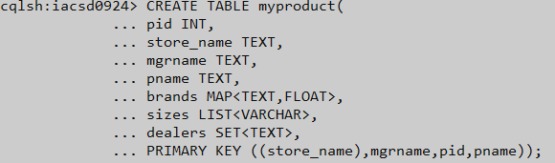

Q.1.

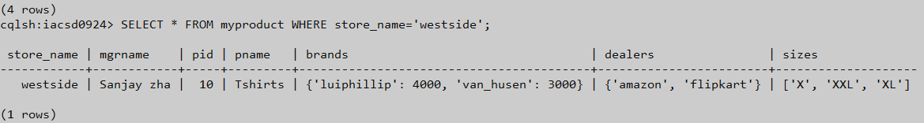

Q.2.

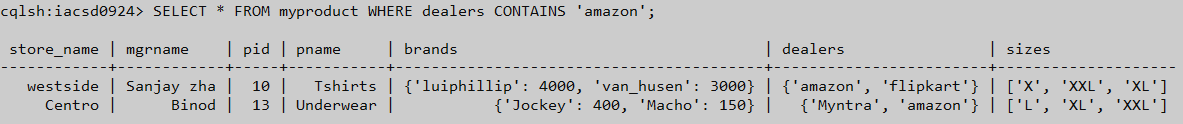

Q.3.



Q.4.



Q.5.

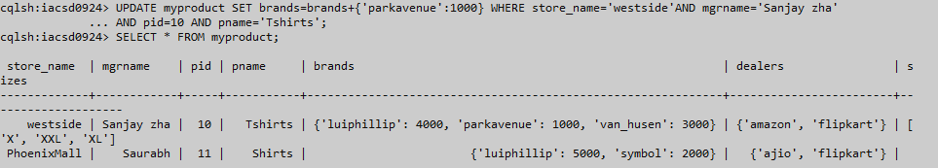

Q.6.

